**Assignment 1,2**

**Problem Statement**

1) Install Google App Engine. Create hello world app and other simple web applications using Java

2) Use GAE launcher to launch the web applications.

**Theory**

**Google App Engine**

Google App Engine (often referred to as GAE or simply App Engine) is a [cloud computing](https://en.wikipedia.org/wiki/Cloud_computing) [platform as a service](https://en.wikipedia.org/wiki/Platform_as_a_service) for developing and hosting [web applications](https://en.wikipedia.org/wiki/Web_application) in Google-managed [data centres](https://en.wikipedia.org/wiki/Data_center). Applications are [sandboxed](https://en.wikipedia.org/wiki/Sandbox_(computer_security)) and run across multiple servers. App Engine offers automatic scaling for web applications—as the number of requests increases for an application, App Engine automatically allocates more resources for the web application to handle the additional demand.

Google App Engine primarily supports [Go](https://en.wikipedia.org/wiki/Go_(programming_language)), [PHP](https://en.wikipedia.org/wiki/PHP), [Java](https://en.wikipedia.org/wiki/Java_(programming_language)), [Python](https://en.wikipedia.org/wiki/Python_(programming_language)), [Node.js](https://en.wikipedia.org/wiki/Node.js), [.NET](https://en.wikipedia.org/wiki/.NET_Framework), and [Ruby](https://en.wikipedia.org/wiki/Ruby_(programming_language)) applications, although it can also support other languages via "custom runtimes". The service is free up to a certain level of consumed resources and only in standard environment but not in flexible environment. Fees are charged for additional storage, [bandwidth](https://en.wikipedia.org/wiki/Bandwidth_(computing)), or instance hours required by the application.

**Steps to install Google App Engine**

**1) Download Eclipse version 4.21**

**2)** Download Google SDK

<https://cloud.google.com/sdk/docs/quickstart>

3) Download the [Google Cloud CLI installer](https://dl.google.com/dl/cloudsdk/channels/rapid/GoogleCloudSDKInstaller.exe).

4) Launch the installer and follow the prompts. The installer is signed by Google LLC.

5) Cloud SDK requires java, supported versions are (4.8 to 4.11). To use Cloud SDK, your operating system must be able to run a supported version of eclipse.

Installation Steps:

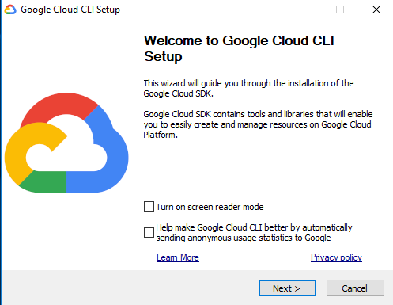

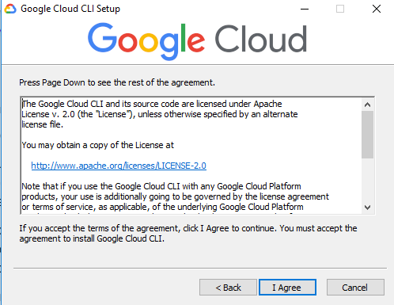

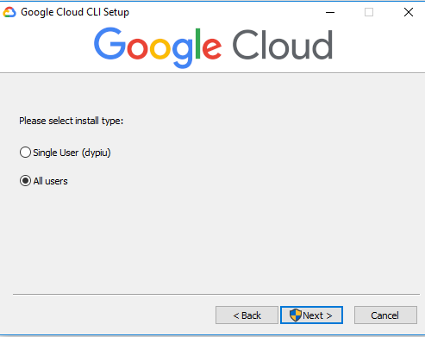

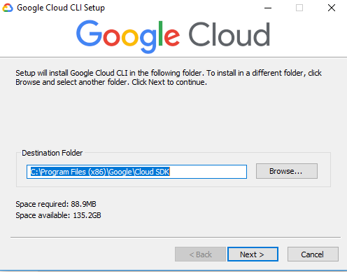

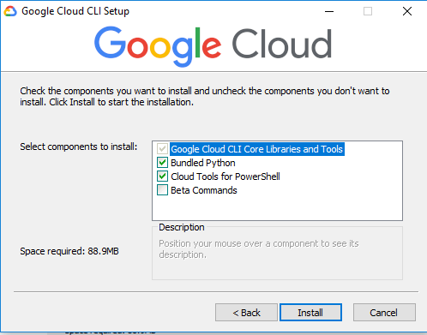

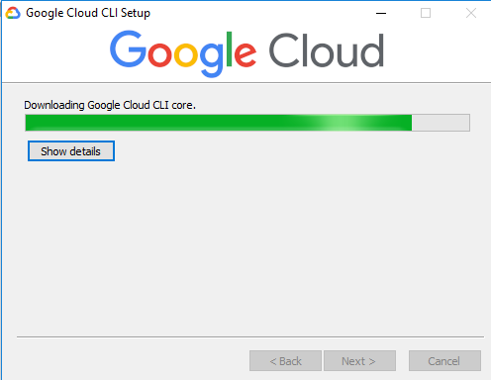

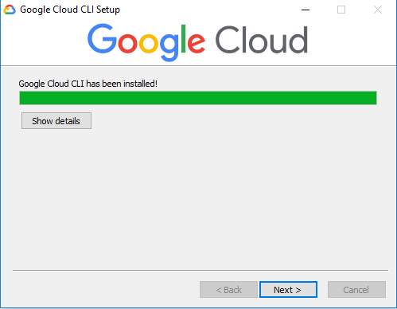

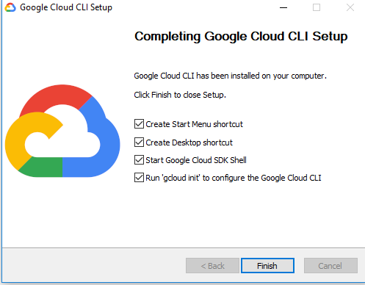

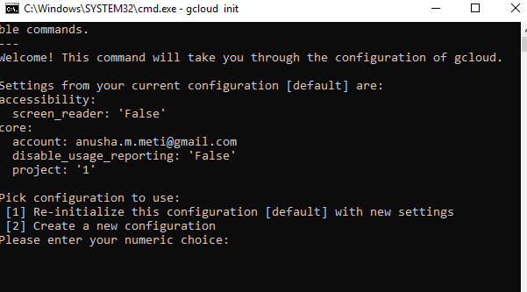

**For Esclipse**

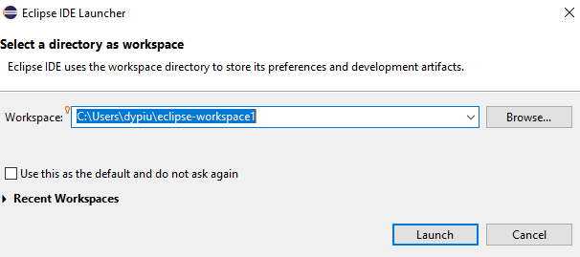

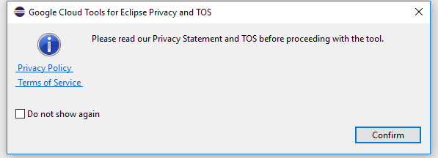

**After this slide attach screenshots of hello world program and deployment of web application in localhost also deploy DYP CAFÉ application on localhost**